Name: Erfan Ahmadbeigi

Master:Milad nourian nasab

Subject:Zone

A DNS zone is **a portion of the DNS namespace that is managed by a specific organization or administrator**. A DNS zone is an administrative space which allows for more granular control of DNS components, such as authoritative nameservers. The domain name space is a hierarchical tree, with the DNS root domain at the top.

What are the types of zones in DNS?

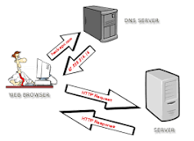

**Broadly speaking, there are five types of DNS zones.**

* Primary zone.
* Secondary zone.
* Active Directory-integrated zone.
* Stub zone.
* Reverse lookup zone.

Doing things on the Internet has become a way of life, but have you ever wondered what really goes on in the background? Say, when you type google.com or espn.com, how does your browser magically display the information you’re looking for? Well, many things come together to make this possible, but the one that we’re going to talk about today is DNS and DNS zones.

What is DNS?

Every device on the Internet has a unique IP address that makes it easy for other devices to identify and communicate with a device. But this IP address is hard for humans to remember because they are a set of numbers. For example, it’s 8.8.4.4 in IPv4 and 2001:4860:4860::8888 in IPv6 for Google.

Since it’s impossible to remember the IP address for every site, the Domain Naming System (DNS) was introduced. This is a mapping system that converts every IP address into a human-readable word like google.com or espn.com.

When you type a URL in the browser, the DNS system immediately looks through its tables, converts the human-readable name into an IP address, searches for a device with this IP, downloads information from it, and displays the same to you — all within about 50 microseconds!

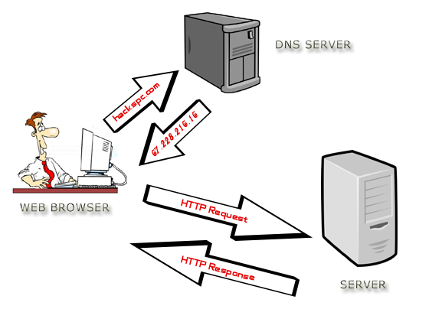[Wikimedia](https://upload.wikimedia.org/wikipedia/commons/4/4f/Dns-server-upload.png)

Since these [DNS servers](https://techgenix.com/azure-dns-build-and-secure-it/) play such an important role in mapping, staying on top of their health and performance at all times is important.

## What are DNS zones?

Your DNS server can have many zones to manage the DNS namespace better. A DNS zone is a part or region of the namespace used as an administrative area to gain more control over some DNS components, such as authoritative namespaces.

In other words, these zones are created for administrative ease and redundancy and help administrators to boost their performance and availability.

You can view the DNS zone as a horizontal platform that cuts across the different subdomains owned by a company. For example, a DNS zone would be applicable for blog.hubspot.com, reports.hubspot.com, and more. But if you view any subdomain as a site by itself that needs dedicated administration, then it requires a separate zone.

All this information about what subdomains come under a DNS zone, the records stored in each, and the contact information of the zone administrator are stored in a DNS zone file. The format is stored as per the [start of authority (SOA) records](https://www.cloudflare.com/learning/dns/dns-records/dns-soa-record/), and the exact information will depend on the type of zone.

### **Primary zone**

The primary zone contains the read/write copy of the zone data, and this information is stored in a text file. The biggest disadvantage of primary DNS zones is that you can change the information only in one location at a time, and this could cause problems when the associated DNS server is down.

### **Active Directory-integrated zone**

The Active Directory-integrated zone overcomes the problems of the primary zone that is heavily reliant on a single DNS server. Here, the primary DNS zone is stored on an Active Directory and not on a DNS zone. In other words, the DNS zone file that contains information about the DNS zone stays in an Active Directory database.

As a result, the DNS zone files follow the same replication procedure as the Active Directory, and more importantly, changes can be done on multiple servers simultaneously. Redundancy is a big advantage of this zone type, as changes can be made on any DNS server. It also supports secure dynamic updates.

However, the limitation is you must install the DNS on a domain controller.

### **Secondary zone**

The secondary zone is a read-only copy of another primary, Active Directory-integrated, or secondary zone. Since it is only a read-only copy, you can’t make any changes to it.

Essentially, the secondary zone passes exchange requests to the primary zone, and it doesn’t require the DNS server to be in the same domain. Also, the secondary zones can be in a non-Windows environment too, and this gives you more flexibility. It’s a good option for redundancy as well.

### **Stub zone**

As the name suggests, a stub zone contains partial data from another zone. It is often the records required to find an authoritative server, which could be a primary or secondary zone containing the DNS zone files.

The biggest advantage of the stub zone is that it automatically updates its records.

### **Reverse lookup zone**

In this zone, the zone file contains a mapping from the IP address to the host. For example, if you have an IP address, you can send it to the DNS zone and get the hostname. These zones are mostly used in troubleshooting where you know the IP address from the log files and want to know the hostname.

Now that you have a good idea of DNS basics and DNS zones, let’s see how you can set up and use them.